**TechConnect Pro Network Architecture Design**

**Name: Gopikrishna Mogilicharla**

**Github URL: https://github.com/gmogilicharla/Project**

**SQL environment (Windows)**

**TechConnect Pro Network Device Management**

**Part 4 a**

**Create Database:**

Create Database TechConnectProDatabase;

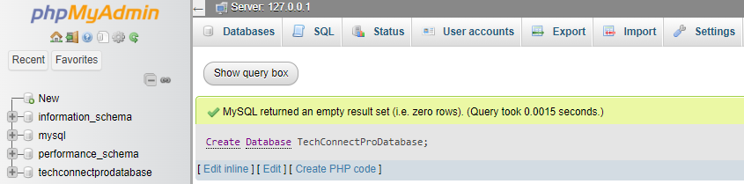

**Create Tables/DDLs:**

|  |
| --- |
| Create Table Product (  ProductID int PRIMARY key ,  ProductName varchar(50),  Category varchar (100),  Price int,  Description varchar (50),  Quantity int  );  create table Supplier(  SupplierID int PRIMARY key ,  SupplierName varchar (50),  Contact varchar(50),  ProductID varchar(50),  FOREIGN KEY (ProductID) REFERENCES Product(ProductID)  );  Create Table Employee (  EmployeeID int PRIMARY key ,  Name varchar(50),  Role varchar (100),  Contact varchar (50)  );  Create table Device(  DeviceID int PRIMARY key ,  DeviceName varchar(50),  Type varchar(50),  Quantity int  );  create table Deploy (  DeployID int PRIMARY key ,  DeviceID int,  ProductID int,  City varchar(50),  FOREIGN KEY (ProductID) REFERENCES Product(ProductID),  FOREIGN KEY (DeviceID) REFERENCES Device(DeviceID)  ) |

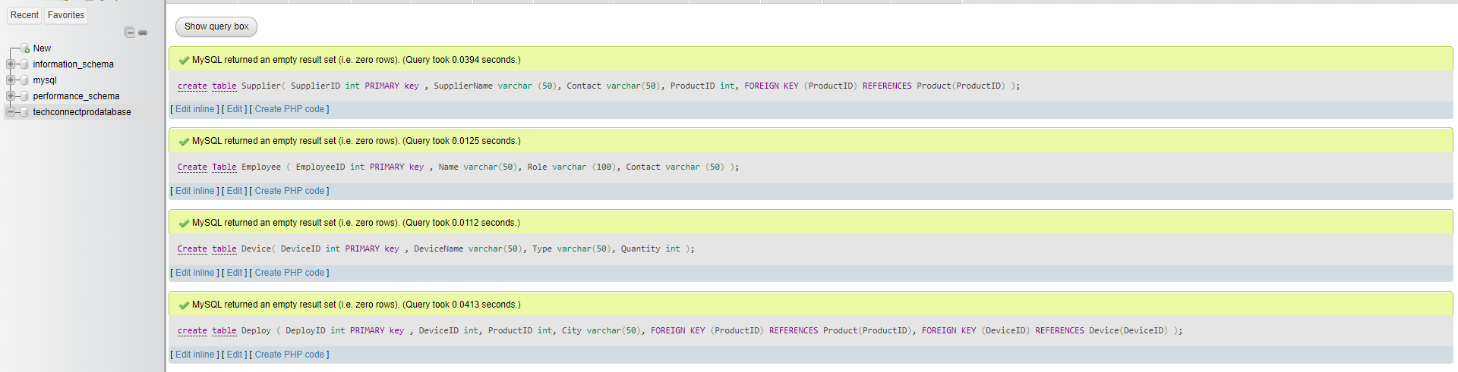

**Load CSV Data Files:**

|  |
| --- |
| LOAD DATA INFILE 'D:\product.csv'  INTO TABLE product  FIELDS TERMINATED BY ','  LINES TERMINATED BY '\n'  IGNORE 1 ROWS;  LOAD DATA INFILE 'D:\supplier.csv'  INTO TABLE supplier  FIELDS TERMINATED BY ','  LINES TERMINATED BY '\n'  IGNORE 1 ROWS;  LOAD DATA INFILE 'D:\deploy.csv'  INTO TABLE deploy  FIELDS TERMINATED BY ','  LINES TERMINATED BY '\n'  IGNORE 1 ROWS;  LOAD DATA INFILE 'D:\employee.csv'  INTO TABLE employee  FIELDS TERMINATED BY ','  LINES TERMINATED BY '\n'  IGNORE 1 ROWS;  LOAD DATA INFILE 'D:\device.csv'  INTO TABLE device  FIELDS TERMINATED BY ','  LINES TERMINATED BY '\n'  IGNORE 1 ROWS; |

|  |
| --- |
| Select * from product;  Select * from supplier;  Select * from device;  Select * from deploy;  Select * from employee; |

